**Use Case Description  
KZ – TPA DESKTOP**

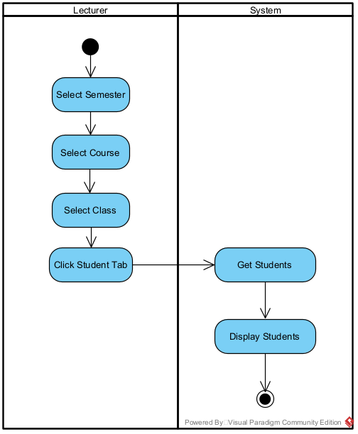

|  |  |  |
| --- | --- | --- |
| Use Case Name | View Students | |
| Scenario | Dosen melihat data mahasiswa melalui Bee Portal | |
| Triggering Event | Dosen ingin melihat mahasiwa dari kelasnya | |
| Brief Description | Dosen dapat melihat mahasiswanya dengan memilih semester, mata kuliah, dan kelas yang dipilih. | |
| Actors | Lecturer | |
| Related Use Cases | - | |
| Stakeholders | Administrative Department | |
| Preconditions | Dosen harus punya minimal 1 kelas yang diajar | |
| Postconditions | Menampilkan Student | |
| Flow of Events | **Actor** | **System** |
| 1. Select semester, course, and class 2. Click Student Tab | * 1. Filter Data   2. Return Student View |
| Exception Conditions | * 1. If there are no data, then the system will show error message | |

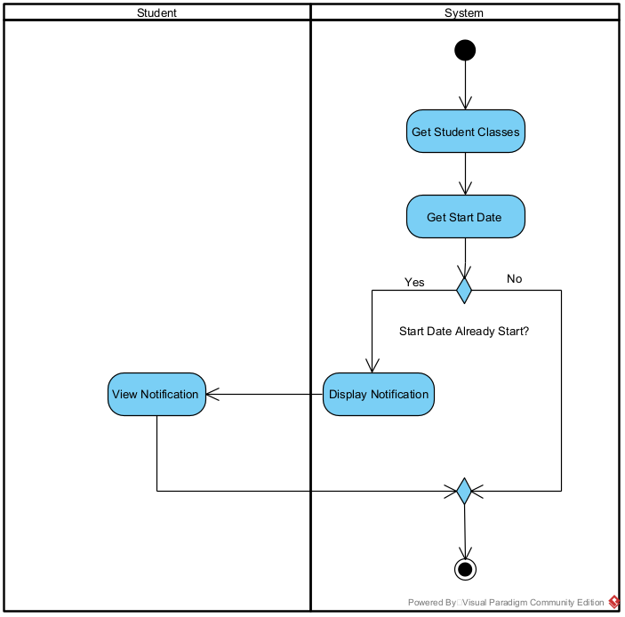

|  |  |  |
| --- | --- | --- |
| Use Case Name | View Notification | |
| Scenario | Mahasiwa melihat notifikasi | |
| Triggering Event | Forum is created/replied, ongoing score protest period | |
| Brief Description | Mahasiswa dapat melihat notifikasi Ketika forum dibuat atau dibahas atau ada ongoing score protest period | |
| Actors | Student | |
| Related Use Cases | - | |
| Stakeholders | - | |
| Preconditions | Mahasiswa harus punya minimal mata kuliah yang diikuti | |
| Postconditions | Melihat notifikasi | |
| Flow of Events | **Actor** | **System** |
| 1. Melihat Notifikasi | * 1. Get Student Data   2. Generate Notifikasi |
| Exception Conditions | * 1. If there are no data, then the system will show error message | |

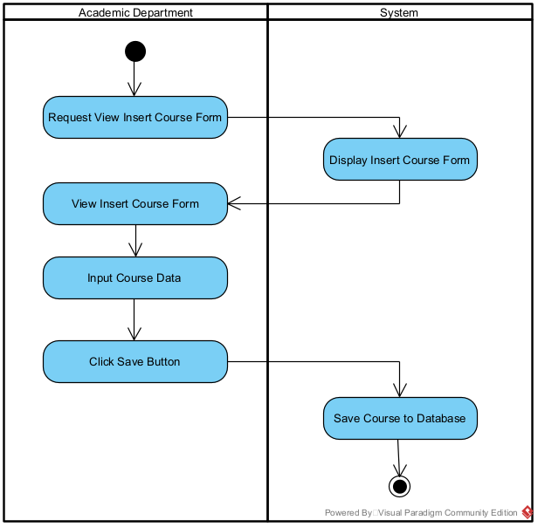

|  |  |  |
| --- | --- | --- |
| Use Case Name | Insert Course | |
| Scenario | Academic Department menambahkan mata kuliah yang tersedia pada SLC University | |
| Triggering Event | Academic Department ingin menambahkan course | |
| Brief Description | Academic Department dapat menambahkan mata kuliah dengan minimal 1 materi | |
| Actors | Academic Department | |
| Related Use Cases | - | |
| Stakeholders | Academic Department | |
| Preconditions | Academic Department harus menginsert materi terlebih dahulu, 1 course mempunyai minimal 1 materi | |
| Postconditions | Click Save Button | |
| Flow of Events | **Actor** | **System** |
| 1. Melihat Notifikasi | * 1. Get Student Data   2. Generate Notifikasi |
| Exception Conditions | * 1. If there are no data, then the system will show error message | |

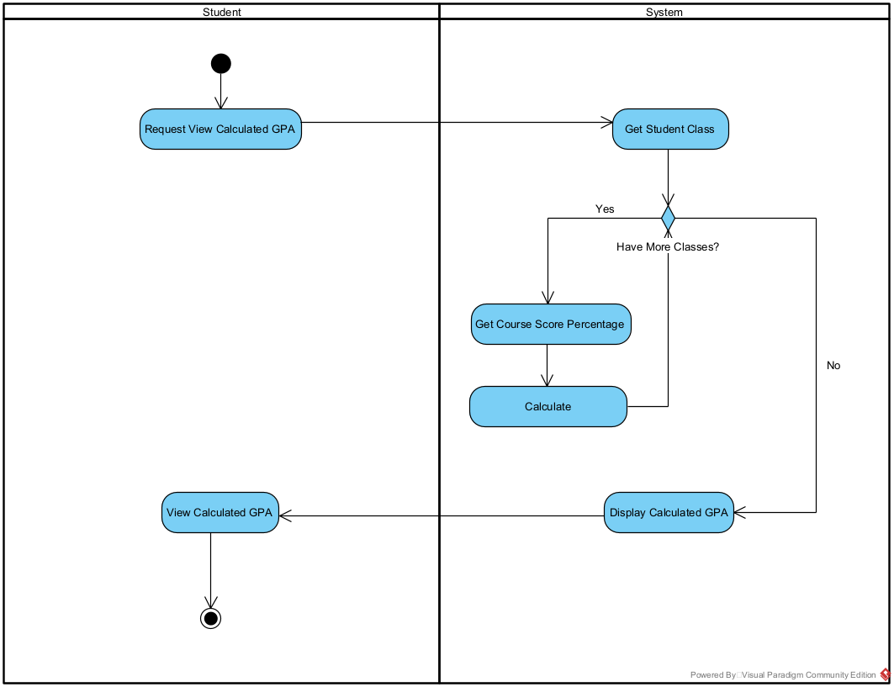

|  |  |  |
| --- | --- | --- |
| Use Case Name | View Calculated GPA | |
| Scenario | Mahasiswa dapat melihat calculated GPA melalui Bee Portal | |
| Triggering Event | Mahasiswa ingin melihat calculated GPA | |
| Brief Description | Mahasiswa dapat melihat calculated GPA | |
| Actors | Student | |
| Related Use Cases | - | |
| Stakeholders | Scoring Department | |
| Preconditions | Mahasiswa minimal harus mempunyai 1 kelas yang semua nilainya sudah terisi | |
| Postconditions | Melihat calculated GPA | |
| Flow of Events | **Actor** | **System** |
| 1. Melihat Calculated GPA | * 1. Menghitung GPA   2. Menampilkan calculated GPA |
| Exception Conditions | * 1. If there are no data, then the system will show error message | |

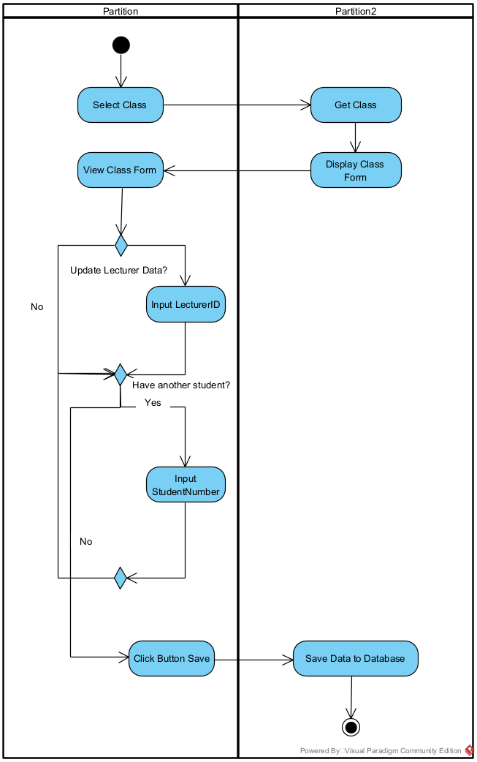

|  |  |  |
| --- | --- | --- |
| Use Case Name | Allocate Lecturers and Students | |
| Scenario | Administrative Department dapat mengalokasikan dosen dan mahasiswa dalam satu kelas melalui Bee Portal | |
| Triggering Event | Administrative Department ingin mengalokasikan dosen dan mahasiswa dalam satu kelas | |
| Brief Description | Administrative Department dapat mengalokasikan dosen dan mahasiswa dalam satu kelas dengan memasukkan lecturer ID dan student number pada satu kelas | |
| Actors | Administrative Department | |
| Related Use Cases | - | |
| Stakeholders | Student, Lecturer | |
| Preconditions | Satu kelas harus memiliki minimal 1 dosen dan 1 mahasiswa | |
| Postconditions | Click Button Save | |
| Flow of Events | **Actor** | **System** |
| 1. Memilih kelas 2. Memasukkan kode dosen dan NIM mahasiswa 3. Mengklik save button | * 1. Menampilkan data dosen dan mahasiswa dalam satu kelas   4.1. Menyimpan data pada database |
| Exception Conditions | * 1. If there are no data, then the system will show error message | |